Assessment - 3 Gradable
1. Go through the string below and if the length of a word is even print "even!"
string = 'I know how to print every word in this sentence that has an even number of letters'
Ans: string = 'I know how to print every word in this sentence that has an even number of letters'

words = string.split()

for w in words:
if len(w) % 2 == 0:
print(w, "→ even!")
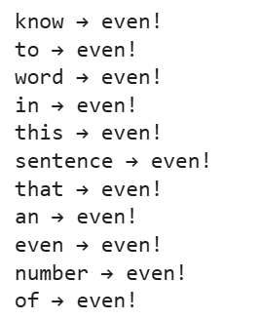
2. Create a function lets_find_88 Given a list of ints, return True if the array contains a 8 next to a 8 somewhere.
- lets_find_88([1, 8, 8]) → True
- lets_find_88([1, 8, 1, 8]) → False
- lets_find_88([8, 1, 8]) → False
Ans: def lets_find_88(nums):
for i in range(len(nums) - 1):
if nums[i] == 8 and nums[i + 1] == 8:
print(True)
return
print(False)

# function calls
lets_find_88([1, 8, 8]) # True
lets_find_88([1, 8, 1, 8]) # False
lets_find_88([8, 1, 8]) # False
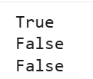
3. Calculate and display the sum of all the numbers divisible by 7 between 18 and 534.
Hint: One way to do this is to loop over a 'range' using 'for' loop and use an 'if' statement inside it.
Ans: total = 0

for num in range(18, 535):
if num % 7 == 0:
total += num

print("Sum of numbers divisible by 7:", total)
4. Create a list containing the following 3 elements:
- Subject person had taken
- Marks Achieved
- a boolean value showing previous programming experience
and Complete the following 'print' and 'if' statements by accessing the appropriate elements from my_list.
Ans: # Creating the list
my_list = ["Python", 85, True]
# [Subject, Marks, Previous programming experience]

# Printing elements by accessing indices
print("Subject taken:", my_list[0])
print("Marks achieved:", my_list[1])
print("Previous programming experience:", my_list[2])

# Using elements in an if-statement
if my_list[2] == True:
print("The person has previous programming experience.")
else:
print("The person does NOT have previous programming experience.")
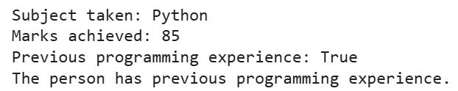
5. Write a function to return True if the first and last number of a given list is same. If numbers are different then return False.
- [11, 13, 17, 19, 11] --> True
- [24, 36, 12, 31, 42] --> False
Ans: def check_first_last(nums):
if nums[0] == nums[-1]:
return True
else:
return False

# Test cases
print(check_first_last([11, 13, 17, 19, 11])) # True
print(check_first_last([24, 36, 12, 31, 42])) # False

